

Master Data Management - User Stories & Wireframes

Contents

Changes 4
1. User Story- Create Scheme 5
1.1 Mock-ups 10
2. User Story - Edit Scheme 21
2.1 Mock-ups 26
3. User Story - View Scheme 37
3.1 Mock-ups 40
4. User Story - Remove Scheme 44
4.1 Mock-ups 45
5. User Story - Manage Property- Add property to a scheme 45
5.1 Mock-ups 47
6. User Story - Edit Property 49
6.1 Mock-ups 50
7. User Story - View Property Details 50
7.1 Mock-ups 52
8. User Story - Remove Property 52
8.1 Mock-ups 54
9. User Story - Manage Notifications- Add Notification to a scheme 54
9.1 Mock-ups 55
10. User Story - Edit Notification 57
10.1 Mock-ups 58
11. User Story - View Notification Details 60
11.1 Mock-ups 61
12. User Story - Remove Notification 61
12.1 Mock-ups 62
13. User Story - Manage Refund- Add Refund to a scheme 63
13.1 Mock-ups 65
14. User Story - Edit Refund 66
14.1 Mock-ups 67
15. User Story - View Refund Details 67
15.1 Mock-ups 69
16. User Story - Remove Refund 69
16.1 Mock-ups 70
17. User Story – Add Circle Rate 70
17.1 Mock-ups 71
18. User Story - Remove Circle Rate 72
18.1 Mock-ups 73
Master Data Management- Backend Data Modeling 73
Master Data- Quota 73
Master Data- Floor 74
Master Data- Rebate 74
Master Data- Sector 75
Master Data- Block 75
Master Data- Department 76
Master Data- Property Subtype 76
Master Data- Location 77
Master Data- Circle Rate 77
Master Data- Payment mode 78
Master Data- Accounts 78
Master Data- Accounts subtype 78
Master Data- Media 79
Master Data- Media subtype 79

Changes

S. No. | Module | Description | Date
1 | 1,2,3 | Added new user stories and mockups for new functionalities. | 07/07/2016
2 | 17,18 | Added new user stories and mockups for new functionalities. | 05/07/2016
3 | Modules | Changes made as per the backlog list. | 04/07/2016
4 | All Modules | Changed Wireframes | 15/06/2016
5 | All Modules | Changes in Buttons | 15/06/2016
6 | All Modules | Acceptance criteria changed. | 15/06/2016
7 | 1,2 | Acceptance Criteria Updated, business rules added for accordions and departments | 06/06/2016
8 | 1.1, 1.2 | Mockups updated | 06/06/2016
9 | 5, 6, 7 | Acceptance Criteria updated | 06/06/2016
10 | 5.1, 6.1, 7.1 | Mockups updated | 06/06/2016
11 | 1, 2, 3 | Bank part updated in create scheme, edit scheme, view scheme. | 26/05/2016
12 | 1.1, 2.1, 3.1 | Mockups related to bank part in scheme – create, edit, view updated. | 26/05/2016
13 | 13, 14, 15 | Manage refund updated- added department name. | 26/05/2016
14 | 13.1, 14.1 | Mockups updated for manage refunds. | 26/05/2016
15 | 15.1, 16.1 | Mockups updated for manage refunds. | 26/05/2016
16 | 9, 10 | Old notification changed to optional | 26/05/2016

User Story- Create Scheme

Sprint | 2
User Story ID | 001
User Story Title | Manage Scheme- Create Scheme
Actors | Admin
Story | As an admin I want to create a scheme.
Pre Conditions | Admin should be logged in to the system.
Business Criteria | - Scheme Id would be auto generated.  - For all other banks, branches and account numbers provided, data should be updated in respective master tables.  - Accordion should be visible one at a time in progressive manner. i.e., it should be accordion 1 then accordion 2 then accordion 3 etc. user directly can’t open accordion 3.  - Departments selected in department accordion would only be visible in subsequent accordions. Not all departments.  - User would not be able to delete any department if it is used in subsequent accordions. User should be given a message to remove department dependencies in subsequent accordions in order to remove department.  - The allotment money % and Installment money % should be equal to 100%  - Property types would be shown as per the departments selected.  - Earnest money (%)should not be greater than allotment money (%)  - There would be one entry for scheme and department for a process schedule for land development.  - In schedule for land development accordion, Duration field value would be saved in no of days only (database), irrespective of the format Year/Month/Day.
Acceptance Criteria | - User would click on ‘Create scheme’ option under ‘Manage Scheme’ menu.  - User would get a screen with a form to create a scheme which would be in several accordions.  - Scheme  - Department  - Quota  - Rebate  - Cost  - Bank Details  Accordion – Scheme  Fields:  - Scheme Name: Textbox (mandatory)  - Scheme Type: Dropdown (mandatory)  - Start Date: Date picker (mandatory)  - End Date: Date picker (mandatory)  User would click on ‘Add’ button to save scheme data, scheme will be added however, scheme will be active with final submit (active Scheme). Once scheme details are added the user would be shown with message as “Scheme added successfully”.  Accordion – Department  User would get a form with below mentioned fields. User would select one department at a time, fill in the fields and click on add to save data in grid. User would not be able to add a department if already added to the grid.  Fields: visible for ‘Housing’ as department  - Normal Interest: Dropdown (mandatory)  - Penal Interest: Dropdown (mandatory)  - Frequency: Dropdown (mandatory type: yearly, half yearly, quarterly, monthly)  - Maximum Number of Installments: Textbox (mandatory)  - Selection Type: Dropdown, values: Draw, Open Ended, Tender (mandatory)  Fields: visible for other department  - Normal Interest: Dropdown (mandatory)  - Penal Interest: Dropdown (mandatory)  - Frequency: Dropdown (mandatory type: yearly, half yearly, quarterly, monthly)  - Maximum Number of Installments: Textbox (mandatory)  - Allotment Money (%): Textbox (mandatory)  - Installment Money (%): Textbox (mandatory)  - Lease Rent (%): Textbox (mandatory)  - Floor Area Ratio (FAR): Textbox (mandatory, decimal x.xx)  - Selection Type: Dropdown, values: Draw, Open Ended, Tender (mandatory)  Accordion – Quota (Optional)  User would select one department at a time, fill in the fields and click on add to save data in grid. User would not be able to add same department-quota type combination if already added to the grid. User would also be able to remove entries from the grid if required  Fields Quota:  - Department: Dropdown (mandatory)  - Quota type: Dropdown (mandatory)  - Value: Textbox (mandatory)  - Unit: Dropdown (mandatory type: no. of units or percentage of units)  Accordion – Rebate (Optional)  User would select one department at a time, fill in the fields and click on add to save data in grid. User would not be able to add same department-rebate combination if already added to the grid. User would also be able to remove entries from the grid if required.  Fields Rebate:  - Department: Dropdown (mandatory)  - Rebate type: Dropdown (mandatory)  - Value: Textbox (mandatory)  - Unit: Dropdown (mandatory type: no. of units or percentage of units)  Accordion – Cost  User would select one department at a time, fill in the fields and click on add to save data in grid. User would not be able to add same department-property subtype-sector combination if already added to the grid. User would also be able to remove entries from the grid if required.  Fields: visible for ‘Housing’ as department  - Department: Dropdown (mandatory)  - Property Type: Dropdown (mandatory)  - Sector: Dropdown (mandatory)  - Floor: Dropdown , (mandatory only in case of flats)  - Block: Dropdown, (mandatory)  - Property Cost (INR): Textbox (mandatory)  - Civil Cost (INR): Textbox (mandatory only in case of housing department and flats as property subtype)  - Total property cost (INR): Textbox (mandatory, auto calculated = Property Cost + Civil Cost)  - Allotment Money (INR): Textbox (mandatory)  - Lease Rent (Yearly) (INR): Textbox (mandatory).  - Earnest Money (INR): Textbox (mandatory)  Fields: visible for other departments  - Department: Dropdown (mandatory)  - Property Type: Dropdown (mandatory)  - Sector: Dropdown (mandatory)  - Block: Dropdown (mandatory)  - Land Rate (per sq.mt.): Textbox (mandatory)  - Earnest Money (INR): Textbox (mandatory)  Accordion – Bank Details  User would get form to add bank, branch and account no, user would click on ‘add’ to save data in grid. User would not be able to add same bank-branch-account combination if already added to the grid. User would also be able to remove entries from the grid if required.  Fields:  - Bank Name: Dropdown (mandatory)  - Branch Address: Dropdown based on selected bank name (mandatory).  - Account Number: Auto populated based on branch name, dropdown (considering the case of multiple account number).  - Note: If user selects ‘Other’ as bank name from dropdown, then three textboxes should be displayed.  - Bank Name: Textbox(mandatory)  - Branch Address: Textbox (mandatory)  - Account Number: Textbox (mandatory)  If user selects bank name from drop down but select ‘others’ as branch  address, then two textboxes should be displayed:  - Branch Address: Textbox (mandatory)  - Account Number: Textbox (mandatory)  If user select appropriate bank name , branch name but selects ‘other’ as account number the one textbox should be displayed:  - Account Number: Textbox (mandatory)  Accordion – Schedule for Land Development  User would get a form with below fields to add schedule for the land development.  Fields:  - Department: Dropdown, Mandatory  - Process Name: Dropdown, Mandatory  - Duration (In Days): Textbox, Mandatory, Format year/month/day.  Year would be no of years, Month would be number of months and day would be no of days. It is not a date.  - Trigger Process: Dropdown, Mandatory  - After filling the form, user would click on Activate Scheme button to activate scheme successfully.  - Once user successfully activated a scheme it would be displayed in a grid on manage scheme screen with following columns:  - Scheme Name  - Scheme Type  - Start Date  - End Date  - Completed (Yes/No)  - Actions: ‘Edit’ & ‘Remove’.  Note: All added entries in accordions would be displayed in their respective grids with remove option.
Field level Validation | - Scheme Name: alphanumeric with only space as special character, maximum 150 characters.  - Start Date: Valid date format  - End Date: Valid Date format  - Maximum Number of Installments: Numeric, 2 characters max.  - FAR: Decimal (3, 2).  - Quota- value: numeric,  3 characters if percentage (max 100) as unit, Total Quota value for all quota in a department should not be more than 100.  If fix, 6 characters max.  - Rebate- value: numeric,  If percentage unit (max value 100), 3 characters maximum and total rebate percentage should not be more than 100 for all rebate in a department.  If INR unit, 15 characters maximum.  - Land rate (Per sq.mtr.): Decimal (15,2)  - Allotment Money: Decimal (15,2)  - Earnest Money: Decimal (15,2)  - Property Cost: Decimal (20,2)  - Civil Cost: Decimal (15,2)  - Lease Rent: Decimal (15,2)  - Bank Name: alphanumeric with only space as special character, maximum 100 characters.  - Branch Address: alphanumeric with only space as special character, maximum 150 characters.  - Account Number: alphanumeric, max 30 characters.  - Duration: Year/Month/Day, numeric only.  Note: All mandatory fields can’t be left blank.

Mock-ups

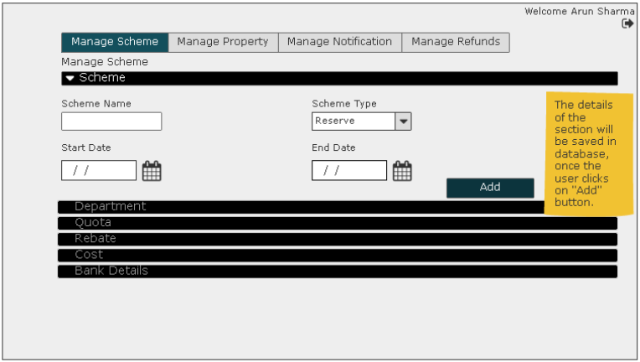
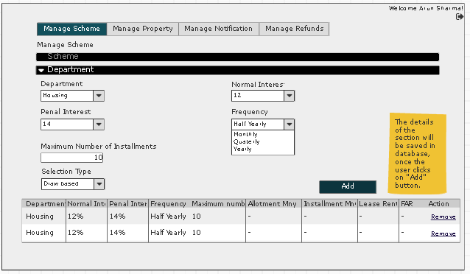
Screen for Housing Department

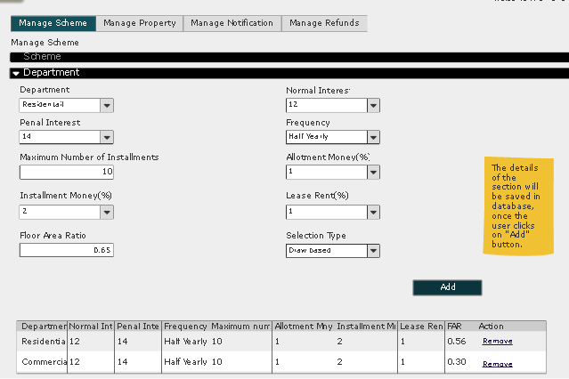
Screen for Other Department

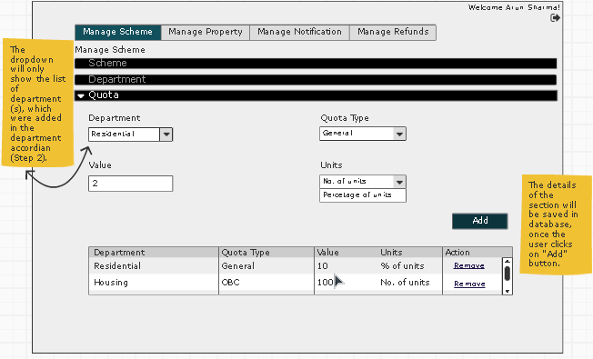
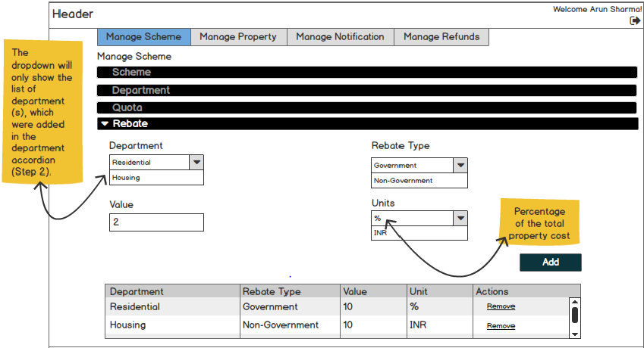
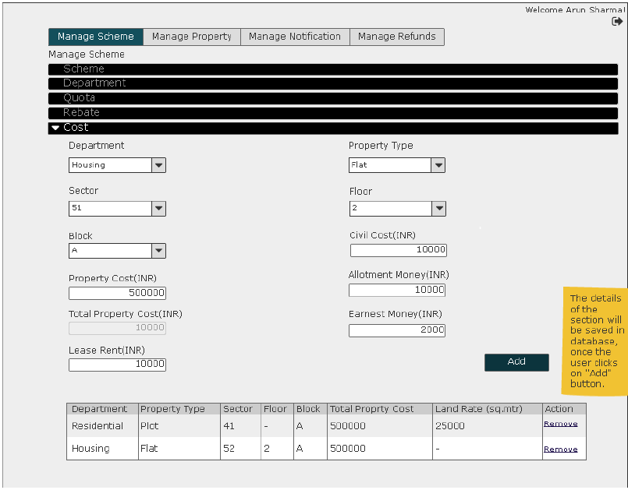
Screen for Housing Department
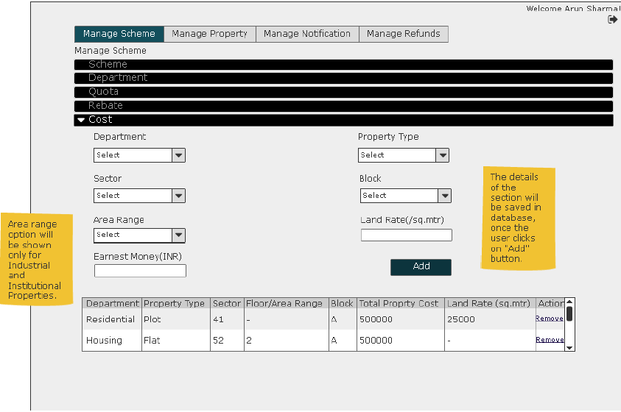
Screen for Other Department

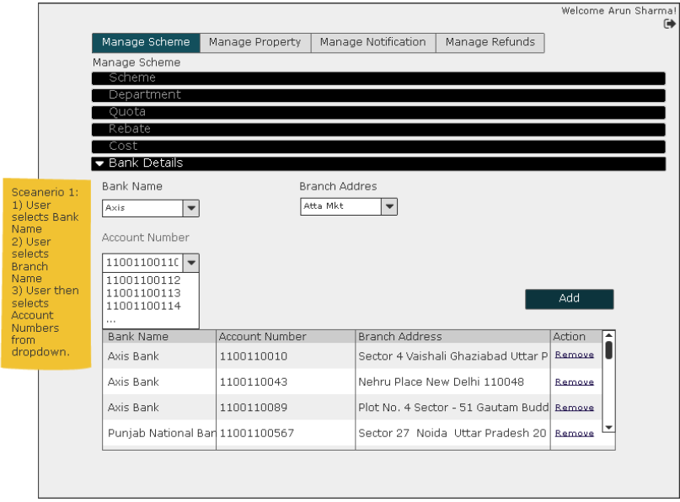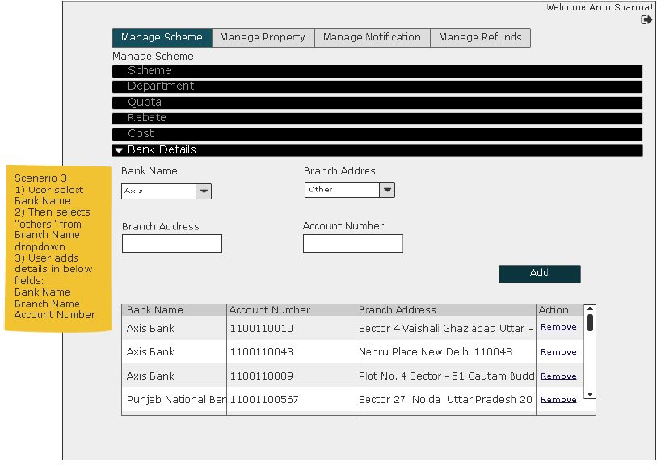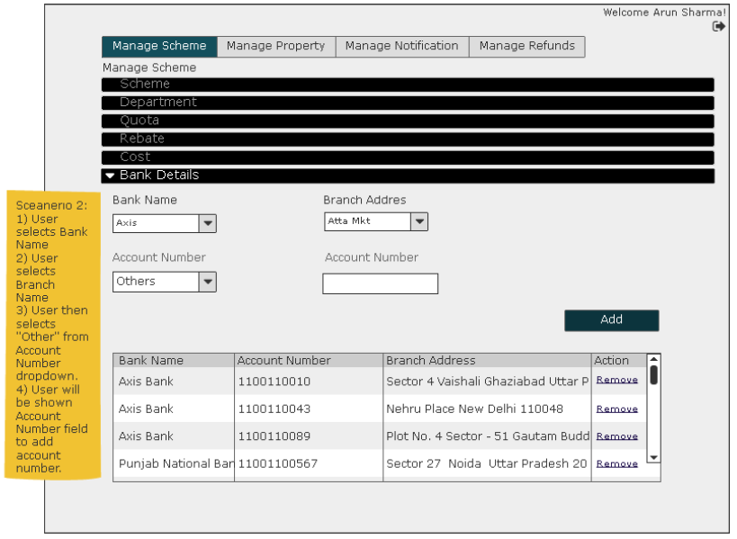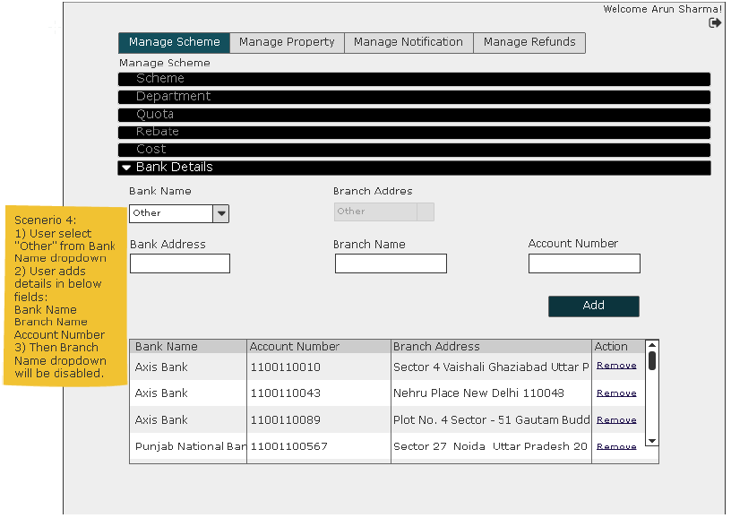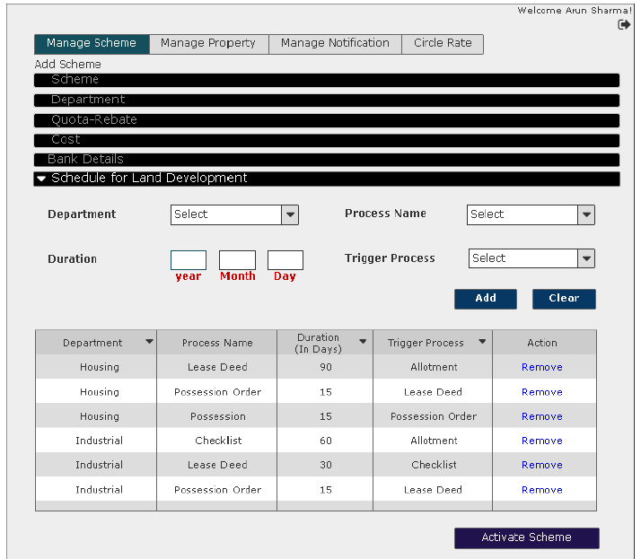

User Story - Edit Scheme

Sprint | 2
User Story ID | 002
User Story Title | Manage Scheme- Edit Scheme
Actors | Admin
Story | As an admin I want to update a scheme details.
Pre Conditions | Admin should be logged in to the system.
Business Criteria | - Scheme Id would be auto generated.  - For all other banks, branches and account numbers provided, data should be updated in respective master tables.  - ‘Edit’ option would not be visible for schemes which has at least one property allotted.  - Accordion should be visible one at a time in progressive manner. i.e., it should be accordion 1 then accordion 2 then accordion 3 etc. user directly can’t open accordion 3.  - Departments selected in department accordion would only be visible in subsequent accordions. Not all departments.  - User would not be able to delete any department if it is used in subsequent accordions. User should be given a message to remove department dependencies in subsequent accordions in order to remove department.  - The allotment money % and Installment money % should be equal to 100%  - Property types would be shown as per the departments selected.  - There would be one entry for scheme and department for a process schedule for land development.  - In schedule for land development accordion, Duration field value would be saved in no of days only (database), irrespective of the format Year/Month/Day.
Acceptance Criteria | - User would click on ‘Edit’ option from the list of option available on ‘Manage Scheme’ grid.  - User would get a screen with a form to update the existing details in several accordions.  - Scheme  - Department  - Quota  - Rebate  - Cost  - Bank Details  Accordion – Scheme  Fields:  - Scheme Name: Textbox (mandatory)  - Scheme Type: Dropdown (mandatory)  - Start Date: Date picker (mandatory)  - End Date: Date picker (mandatory)  User would click on ‘Update’ button to save updated details.  Accordion – Department  User would get a form with below mentioned fields. User would select one department at a time, fill in the fields and click on add to save data in grid. User would not be able to add a department if already added to the grid.  Fields: visible for ‘Housing’ as department  - Normal Interest: Dropdown (mandatory)  - Penal Interest: Dropdown (mandatory)  - Frequency: Dropdown (mandatory type: yearly, half yearly, quarterly, monthly)  - Maximum Number of Installments: Textbox (mandatory)  - Selection Type: Dropdown, values: Draw, Open Ended, Tender (mandatory)  Fields: visible for other department  - Normal Interest: Dropdown (mandatory)  - Penal Interest: Dropdown (mandatory)  - Frequency: Dropdown (mandatory type: yearly, half yearly, quarterly, monthly)  - Maximum Number of Installments: Textbox (mandatory)  - Allotment Money (%): Dropdown (mandatory)  - Installment Money (%): Dropdown (mandatory)  - Lease Rent (%): Dropdown (mandatory)  - Floor Area Ratio (FAR): Textbox (mandatory, decimal x.xx)  Accordion – Quota (Optional)  User would select one department at a time, fill in the fields and click on add to save data in grid. User would not be able to add same department-quota type combination if already added to the grid. User would also be able to remove entries from the grid if required  Fields Quota:  - Department: Dropdown (mandatory)  - Quota type: Dropdown (mandatory)  - Value: Textbox (mandatory)  - Unit: Dropdown (mandatory type: percentage or fix)  Accordion – Rebate (Optional)  User would select one department at a time, fill in the fields and click on add to save data in grid. User would not be able to add same department-rebate combination if already added to the grid. User would also be able to remove entries from the grid if required.  Fields Rebate:  - Department: Dropdown (mandatory)  - Rebate type: Dropdown (mandatory)  - Value: Textbox (mandatory)  - Unit: Dropdown (mandatory type: percentage or INR)  Accordion – Cost  User would select one department at a time, fill in the fields and click on add to save data in grid. User would not be able to add same department-property subtype-sector combination if already added to the grid. User would also be able to remove entries from the grid if required.  Fields: visible for ‘Housing’ as department  - Department: Dropdown (mandatory)  - Property Type: Dropdown (mandatory)  - Sector: Dropdown (mandatory)  - Floor: Dropdown , (mandatory only in case of flats)  - Block: Dropdown, (mandatory)  - Property Cost (INR): Textbox (mandatory)  - Civil Cost (INR): Textbox (mandatory only in case of housing department and flats as property subtype)  - Total property cost (INR): Textbox (mandatory, auto calculated = Property Cost + Civil Cost)  - Allotment Money (INR): Textbox (mandatory)  - Lease Rent (INR): Textbox (mandatory).  Fields: visible for other departments  - Department: Dropdown (mandatory)  - Property Type: Dropdown (mandatory)  - Sector: Dropdown (mandatory)  - Land Rate (per sq.mt.): Textbox (mandatory)  - Earnest Money (INR): Textbox (mandatory)  Accordion – Bank  User would get form to edit bank, branch and account no, user would click on ‘edit’ to save data in grid. User would not be able to add same bank-branch-account combination if already added to the grid. User would also be able to remove entries from the grid if required.  Fields:  - Bank Name: Dropdown (mandatory)  - Branch Address: Dropdown based on selected bank name (mandatory).  - Account Number: Auto populated based on branch name, dropdown (considering the case of multiple account number).  - Note: If user selects ‘Other’ as bank name from dropdown, then three textboxes should be displayed.  - Bank Name: Textbox(mandatory)  - Branch Address: Textbox (mandatory)  - Account Number: Textbox (mandatory)  If user selects bank name from drop down but select ‘others’ as branch address then two textboxes should be displayed:  - Branch Address: Textbox (mandatory)  - Account Number: Textbox (mandatory)  If user select appropriate bank name , branch name but selects ‘other’ as account number the one textbox should be displayed:  - Account Number: Textbox (mandatory)  Accordion – Schedule for Land Development  User would get a form with below fields to edit schedule for the land development.  Fields:  - Department: Dropdown, Mandatory  - Process Name: Dropdown, Mandatory  - Duration (In Days): Textbox, Mandatory, Format year/month/day.  Year would be no of years, Month would be number of months and day would be no of days. It is not a date.  - Trigger Process: Dropdown, Mandatory  - After updating the form, user would click on Activate Scheme button to update scheme successfully.  Note: All added entries in accordions would be displayed in their respective grids with remove option.
Field level Validation | - Maximum number of Installments: Numeric, 2 characters max.  - FAR: Decimal (3, 2).  - Quota- value: numeric,  3 characters if percentage (max 100) as unit, Total Quota value for all quota in a department should not be more than 100.  If fix, 6 characters max.  - Rebate- value: numeric,  If percentage unit (max value 100), 3 characters maximum and total rebate percentage should not be more than 100 for all rebate in a department.  If INR unit, 15 characters maximum.  - Land rate (Per sq.mtr.): Decimal (15,2)  - Allotment Money: Decimal (15,2)  - Earnest Money: Decimal (15,2)  - Property Cost: Decimal (20,2)  - Civil Cost: Decimal (15,2)  - Lease Rent: Decimal (15,2)  - Bank Name: alphanumeric with only space as special character, maximum 100 characters.  - Branch Name: alphanumeric with only space as special character, maximum 150 characters.  - Account Number: alphanumeric, max 30 characters.  - Bank Name: alphanumeric with only space as special character, maximum 100 characters.  - Branch Address: alphanumeric with only space as special character, maximum 150 characters.  - Account Number: alphanumeric, max 30 characters.  - Duration: Year/Month/Day, numeric only.  Note: All mandatory fields can’t be left blank.

Mock-ups

Screen for Housing Department

Screen for Other Department

Screen for Housing Department
Screen for Other Department

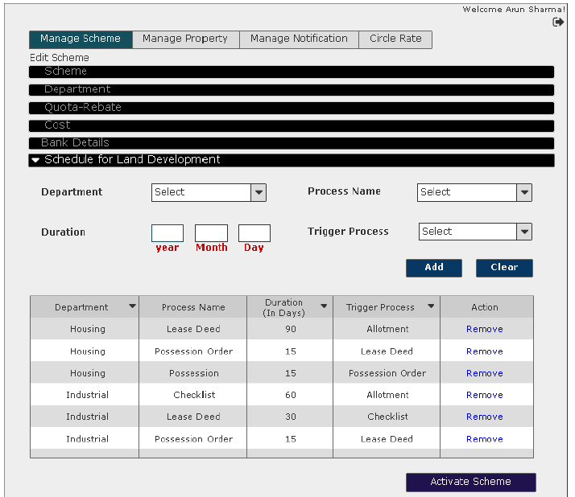

User Story - View Scheme

Sprint | 2
User Story ID | 003
User Story Title | Manage Scheme- View Scheme
Actors | Admin
Story | As an admin I want to view a scheme details.
Pre Conditions | Admin should be logged in to the system.
Business Criteria
Acceptance Criteria | - User would click on ‘Scheme Name’ to view the details of scheme from the set of options available in grid against each scheme created.  - User would get a screen with complete scheme name label along with the scheme details:  - Scheme Name  - Scheme Type  - Start Date  - End Date  - Department details (grid)  - Department (name)  - Normal Interest  - Penal Interest  - Frequency  - Maximum Number of Installments  - Allotment Money %  - Installment Money %  - Lease Rent %  - FAR  - Quota Details (grid)  - Department (name)  - Quota Type  - Value  - Units  - Rebate Details (grid)  - Department (name)  - Rebate Type  - Value  - Units  - Cost (grid)  - Department  - Property Type  - Sector  - Block  - Floor  - Property Cost  - Allotment Money  - Earnest Money  - Lease Rent  - Civil Cost  - Total Property Cost  - Land Rate (per sqmt)  - Bank and branch details (grid)  - Bank (name)  - Account Number  - Branch (address)  - Schedule for land development (grid)  - Department  - Process Name  - Duration (In Days)  - Trigger Process  - User clicks on the “Scheme Name” from the grid and is displayed the view scheme details page. User will be shown the “Edit Scheme” hyperlink to edit the scheme.
Field level Validation

Mock-ups
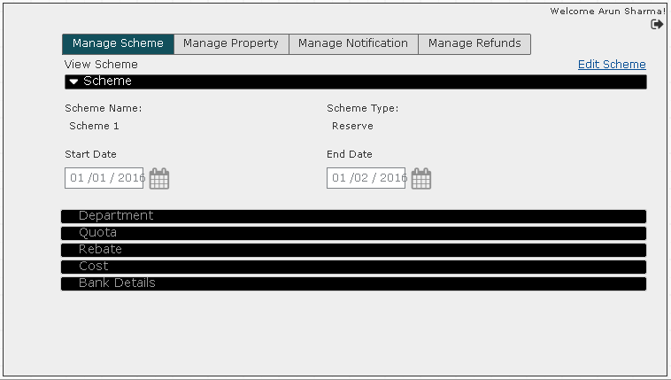
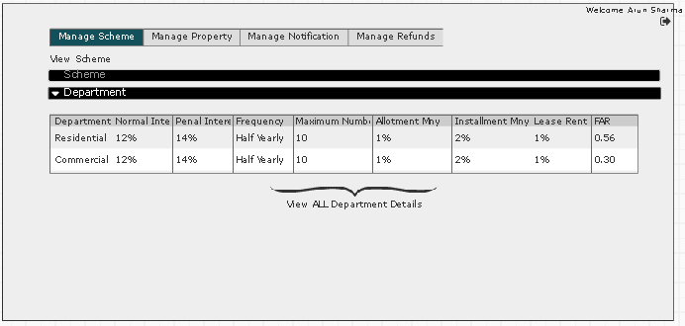
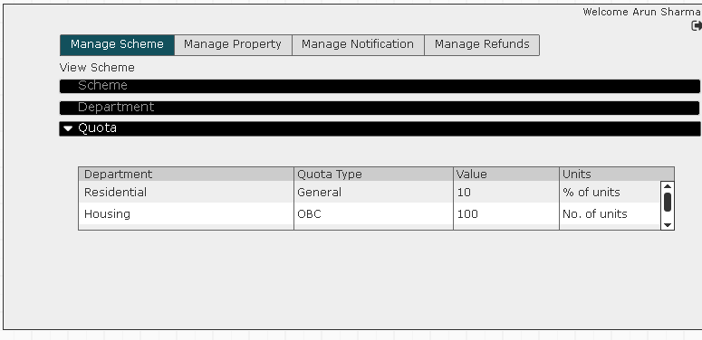
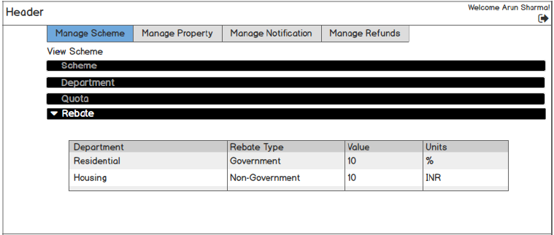

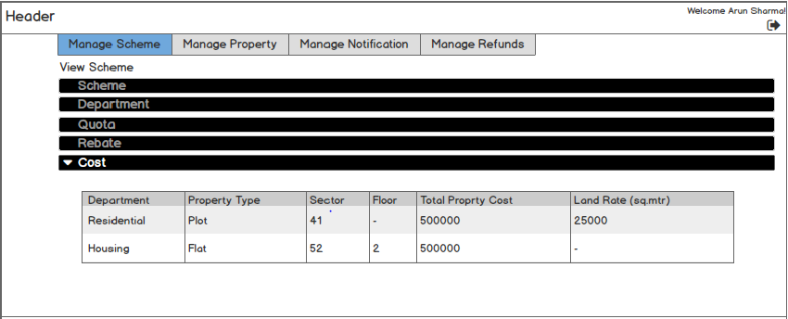
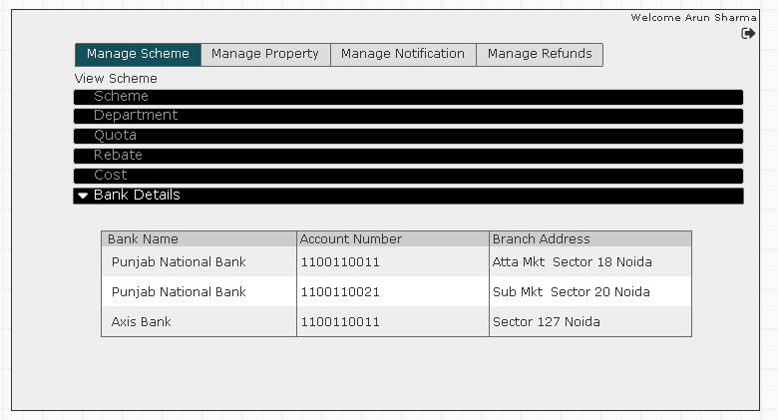

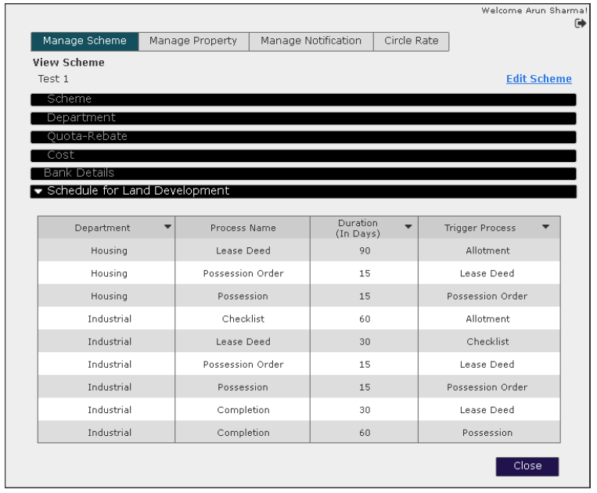

User Story - Remove Scheme

Sprint | 2
User Story ID | 004
User Story Title | Manage Scheme- Remove Scheme
Actors | Admin
Story | As an admin I want to remove a scheme.
Pre Conditions | Admin should be logged in to the system.
Business Criteria | - ‘Remove’ option would not be visible for schemes which has at least one property allotted.  - All removed schemes would only be a soft delete.
Acceptance Criteria | - User would click on ‘Remove’ option from the set of options available in grid against each scheme created.  - User would get pop up box with message as “Are you sure you want to delete?”.  - User clicks on “Ok” button and scheme is deleted from the grid.
Field level Validation

Mock-ups

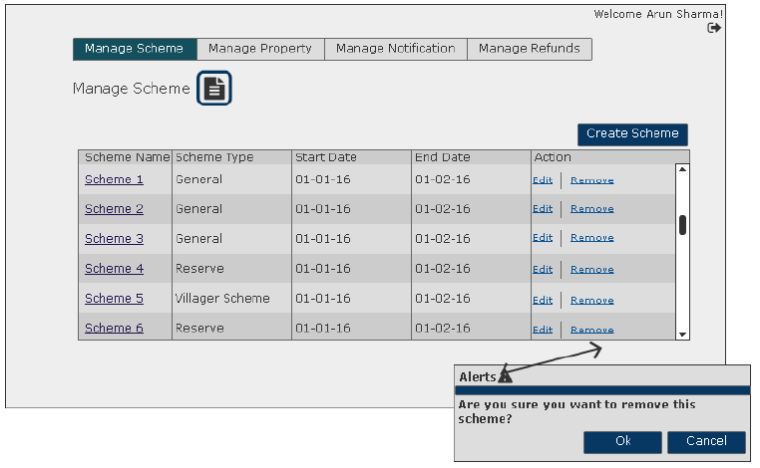

User Story - Manage Property- Add property to a scheme

Sprint | 2
User Story ID | 005
User Story Title | Manage Property- Add property
Actors | Admin
Story | As an Admin I want to add a property in a scheme.
Pre Conditions | - Admin should be logged in to the system.
Business Criteria | - Property Id should be auto generated.  - In case of departments excluding housing:  Total Property cost = Land Rate ( per sqmt) x Total Area  - Effective Property Cost = Total Property Cost + Location Charges.  - Combination of Sector, block and property No would be used to uniquely identify a property :  Format - ‘Sector/Block-PropertyNo’ e.g., 22/B-102.
Acceptance Criteria | - User would click on ‘Add Property’ button under ‘Manage Property’ menu.  - User would get a form with the following fields:  - Scheme Name: Dropdown (mandatory)  - Department: Dropdown (mandatory)  - Property Type: Dropdown (mandatory)  - Sector: Dropdown (mandatory)  - Block: Dropdown (mandatory)  - Property No/Plot No: Textbox (mandatory)  - Floor: Dropdown (mandatory in case of housing as department and flat as property type)  - Total Area (sqmt): Textbox (mandatory)  - Actual Area (sqmt): Textbox (mandatory)  - Covered Area (sqmt): Textbox  - Total Property Cost (INR): Disabled textbox (auto filled)  - Location type: Dropdown  - Location charge (INR): Textbox (mandatory)  - After filling the form, user would click on ‘Add’ button to add property successfully or alternatively, user can click on ’Cancel’ button to return to the ‘Manage Property’ screen.  - Once user successfully added a property to a scheme it would be displayed in a grid on manage property screen with following columns:  - Scheme Name  - Department  - Property Type  - Sector  - Block  - Property No/ Plot No  - Actions: ‘Edit’ & ‘Remove’.
Field Level Validation | - Total Area: Decimal (15,2) max  - Property No: Alphanumeric, maximum 10 characters. Allow ‘/’ and ‘-‘as special character.Check for unique combination of Sector, Block and Property No in the format: Sector/Block-Property No.  - Covered Area: Decimal (13,2) max  - Actual Area: Decimal (13,2) max  - Location Charge: Decimal (15,2) max

Mock-ups

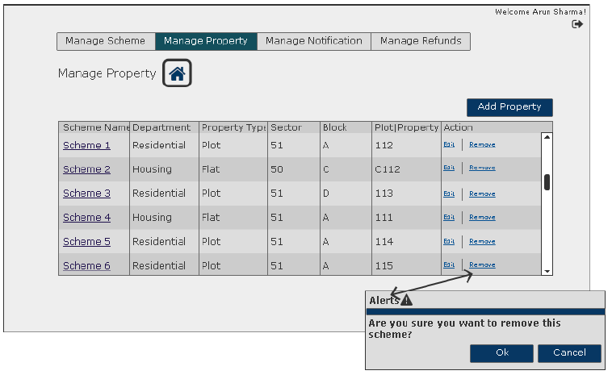
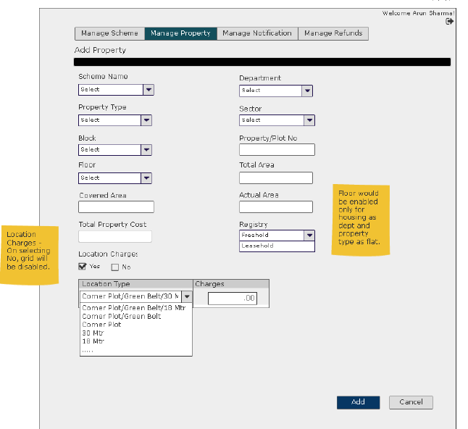

User Story - Edit Property

Sprint | 2
User Story ID | 006
User Story Title | Manage Properties- Edit property
Actors | Admin
Story | As an Admin I want to edit property details
Pre Conditions | - Admin should be logged in to the system.
Business Criteria | - In case of departments excluding housing:  Total Property cost = Land Rate ( per sqmt) x Total Area  - Effective Property Cost = Total Property Cost + Location Charges.  - Combination of Sector, block and property No would be used to uniquely identify a property :  Format - ‘Sector/Block-PropertyNo’ e.g., 22/B-102.  - ‘Edit’ option would not be visible for properties, which were once allotted.
Acceptance Criteria | - User would click on ‘Edit’ option from the set of options available in grid against each Property created.  - User would get a form with the following fields:  - Scheme Name: Dropdown (mandatory)  - Department: Dropdown (mandatory)  - Property Type: Dropdown (mandatory)  - Sector: Dropdown (mandatory)  - Block: Dropdown (mandatory)  - Property No/Plot No: Textbox (mandatory)  - Floor: Dropdown (If housing)  - Total Area (sqmt): Textbox (mandatory)  - Actual Area (sqmt): Textbox (mandatory)  - Covered Area (sqmt): Textbox  - Total Property Cost (INR): Disabled textbox (auto filled)  - Location type: Dropdown  - Location charge (INR): Textbox (mandatory)  - After updating the form, user would click on ‘Update’ button to update property successfully or alternatively, user can click on ’Cancel’ button to return to the ‘Manage Property’ screen without making any changes.
Field Level Validation | - Total Area: Decimal (15,2) max  - Covered Area: Decimal (13,2) max  - Actual Area: Decimal (13,2) max  - Location Charge: Decimal (15,2) max

Mock-ups

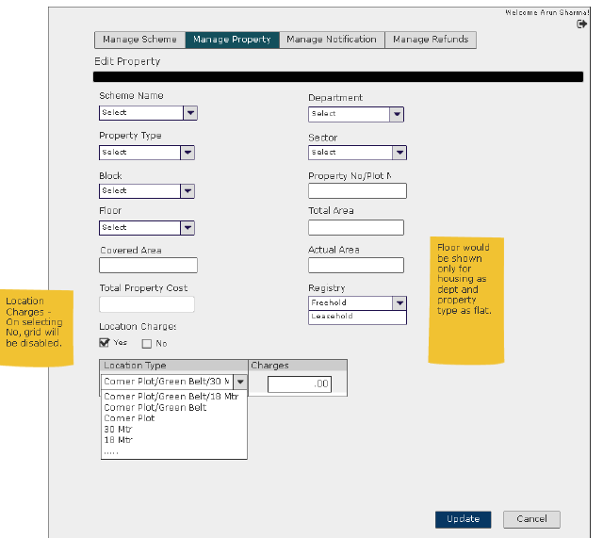

User Story - View Property Details

Sprint | 2
User Story ID | 007
User Story Title | Manage Properties-View property
Actors | Admin
Story | As an Admin I want to view property details
Pre Conditions | - Admin should be logged in to the system.
Business Criteria
Acceptance Criteria | - User would click on ‘Scheme Name’ option from the set of options available in grid against each Property created to view deatils.  - User would get a screen with the following Details:  - Scheme Name  - Department  - Property Type  - Sector  - Block  - Property No/Plot No  - Floor (if Housing)  - Total Area (sqmt)  - Actual Area (sqmt)  - Covered Area (sqmt)  - Property Cost (INR) (if Housing)  - Civil Cost (INR) (if housing)  - Total Property Cost (INR)  - Land Rate (INR)(All departments except ‘housing’)  - Location Type  - Location Charge (INR)  - Allotment Money (INR) (if Housing)  - Lease Rent (INR) (if Housing)  - Allotment Money (%) (All departments except ‘housing’)  - Installment Money (%)(All departments except ‘housing’)  - Lease Rent (%)(All departments except ‘housing’)  - FAR (All departments except ‘housing’)
Field Level Validation

Mock-ups

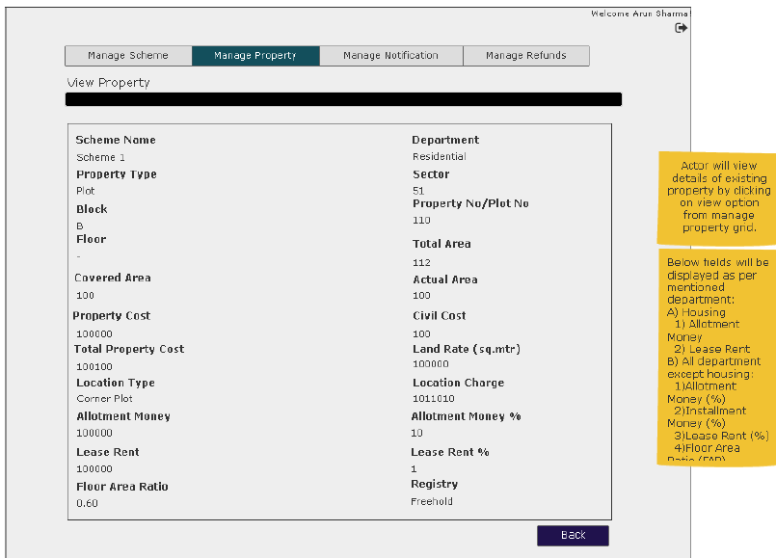

User Story - Remove Property

Sprint | 2
User Story ID | 008
User Story Title | Manage Property- Remove Property
Actors | Admin
Story | As an admin I want to remove a property.
Pre Conditions | Admin should be logged in to the system.
Business Criteria | - ‘Remove’ option would not be visible for properties, which were once allotted.  - All removed properties would only be a soft delete.
Acceptance Criteria | - User would click on ‘Remove’ option from the set of options available in grid against each property created.  - User would get pop up box with message as “Are you sure you want to delete?”.  - User clicks on “Ok” button and scheme is deleted from the grid.
Field level Validation

Mock-ups
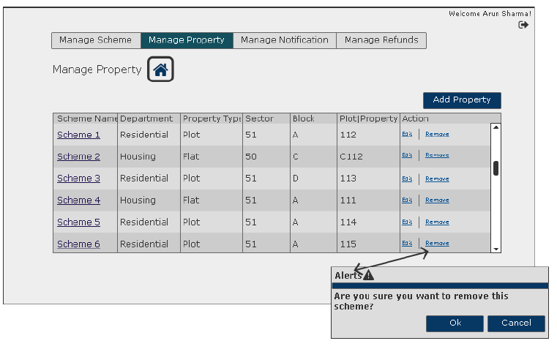

User Story - Manage Notifications- Add Notification to a scheme

Sprint | 2
User Story ID | 009
User Story Title | Manage Notifications- Add Notification
Actors | Admin
Story | As an Admin I want to add a notification of a scheme.
Pre Conditions | - Admin should be logged in to the system.
Business Criteria | - Notification Id should be auto generated.  - There would be only one notification per scheme.
Acceptance Criteria | - User would click on ‘Add Notification’ button under ‘Manage Notifications’ menu.  - User would get a form with the following fields:  - Scheme Name: Dropdown (mandatory)  - Notification Name: Textbox (mandatory)  - Notification Start Date: Date picker (mandatory)  - Notification End Date: Date picker (mandatory)  - Media Type: multi select Dropdown (mandatory)  - Booklet Cost: Textbox (mandatory)  - Scheme Payment Modes: Multi select dropdown (mandatory)  - Old Notification : Dropdown (optional)  - After filling the form, user would click on ‘Add’ button to add notification successfully or alternatively, user can click on ’Cancel’ button to return to the ‘Manage Property’ screen.  - Once user successfully added a notification of a scheme it would be displayed in a grid on manage notification screen with following columns:  - Scheme Name  - Notification Name  - Old Notification  - Actions: ‘Edit’ & ‘Remove’.
Field Level Validation | - Notification Name: alphanumeric with only space as special character, maximum 150 characters.  - Booklet Cost: Numeric, Max 4 characters.  Note: All mandatory fields can’t be left blank.

Mock-ups

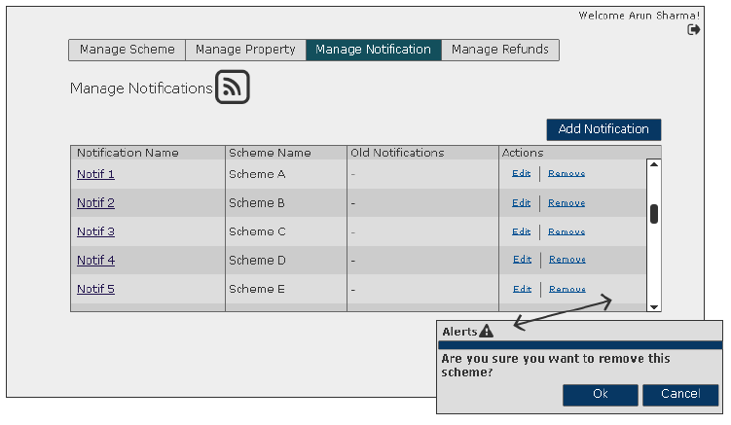

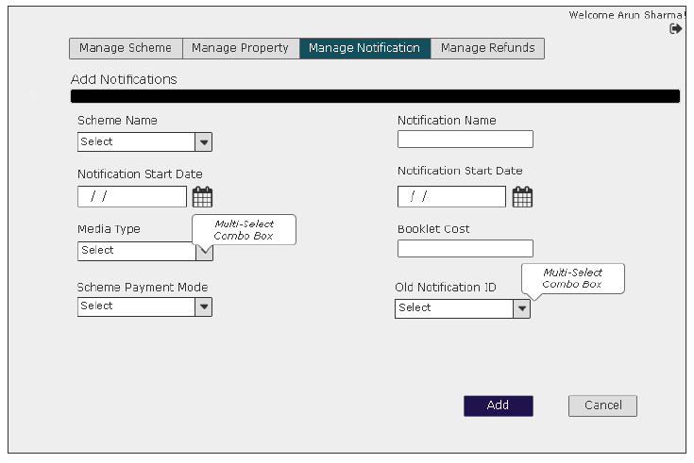

User Story - Edit Notification

Sprint | 2
User Story ID | 010
User Story Title | Manage Notification- Edit Notification
Actors | Admin
Story | As an admin I want to update a notification.
Pre Conditions | Admin should be logged in to the system.
Business Criteria | - Notification Id would be auto generated.  - There would be only one notification per scheme.
Acceptance Criteria | - User would click on ‘Edit’ option from the set of options available in grid against each notification created.  - User would get a form with the following fields:  - Scheme Name: Dropdown (mandatory)  - Notification Name: Textbox (mandatory)  - Notification Start Date: Date picker (mandatory)  - Notification End Date: Date picker (mandatory)  - Media Type: multi select Dropdown (mandatory)  - Media Subtype: multi select Dropdown (mandatory)  - Booklet Cost: Textbox (mandatory)  - Scheme Payment Modes: Multi select dropdown (mandatory)  - Old Notification ID: Dropdown (optional)  - After editing the form, user would click on ‘Update’ button to update notification successfully or alternatively, user can click on ’Cancel’ button to return to the ‘Manage Notification’ screen without making any changes
Field level Validation | - Notification Name: alphanumeric with only space as special character, maximum 150 characters. Validate for unique notification name.  - Booklet Cost: Numeric, Max 4 characters.  Note: All mandatory fields can’t be left blank.

Mock-ups

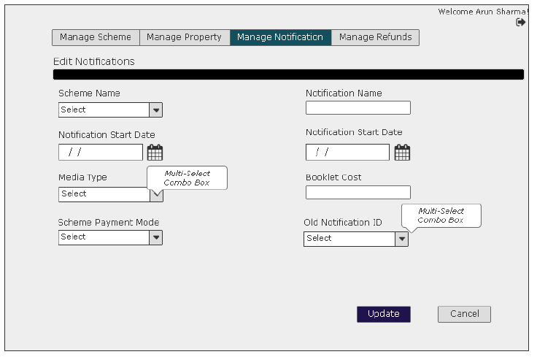

User Story - View Notification Details

Sprint | 2
User Story ID | 011
User Story Title | Manage Notification- View Notification
Actors | Admin
Story | As an admin I want to view a notification.
Pre Conditions | Admin should be logged in to the system.
Business Criteria
Acceptance Criteria | - User would click on ‘Notification Name’ option from the set of options available in grid against each notification created to view the details.  - User would get a screen with the following details:  - Scheme Id  - Scheme Name  - Notification Name  - Notification Start Date  - Notification End Date  - Media Types & Subtypes  - Booklet Cost  - Scheme Payment Modes  - Old Notification ID (if any)
Field level Validation

Mock-ups

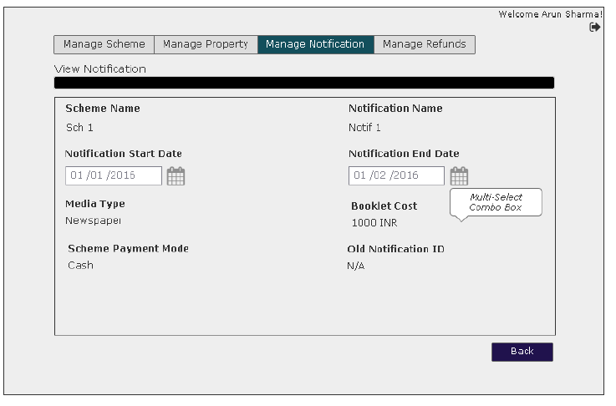

User Story - Remove Notification

Sprint | 2
User Story ID | 012
User Story Title | Manage Notification- Remove Notification
Actors | Admin
Story | As an admin I want to remove a notification.
Pre Conditions | Admin should be logged in to the system.
Business Criteria | - All removed notifications would only be a soft delete.
Acceptance Criteria | - User would click on ‘Remove’ option from the set of options available in grid against each notification created.  - User would get pop up box with message as “Are you sure you want to delete?”.  - User clicks on “Ok” button and scheme is deleted from the grid.
Field level Validation

Mock-ups

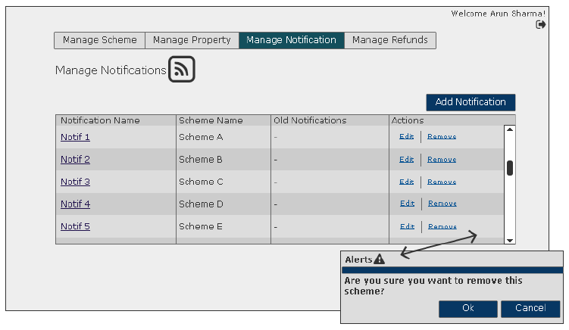

User Story - Manage Refund- Add Refund to a scheme

Sprint | 2
User Story ID | 013
User Story Title | Manage Refund- Add Refund
Actors | Admin
Story | As an Admin I want to add a refund to a scheme.
Pre Conditions | - Admin should be logged in to the system.
Business Criteria | - Refund Id should be auto generated.
Acceptance Criteria | - User would click on ‘Add Refund’ button under ‘Manage Refund’ menu.  - User would get a form with the following fields:  - Scheme Name: Dropdown (mandatory)  - Department Name: Dropdown (mandatory)  - Refund Description: Textbox (mandatory)  - Refund lock period (no of days): Textbox (mandatory)  - Deduction: Textbox (mandatory)  - Unit: Dropdown (mandatory)  - Deduction Apply on: Dropdown (mandatory)  - Interest Rate: Textbox (mandatory)  - Days after Interest: Textbox (mandatory)  - After filling the form, user would click on ‘Add’ button to add refund successfully or alternatively, user can click on ’Cancel’ button to return to the ‘Manage Refund’ screen.  - Once user successfully added a refund to a scheme it would be displayed in a grid on manage refund screen with following columns:  - Scheme Name  - Department Name  - Refund description  - Actions: ‘Edit’ & ‘Remove’.
Field Level Validation | - Refund Description: alphanumeric with only space as special character, maximum 200 characters. Validate for unique notification name.  - Refund Lock Period: Numeric, Max 5 characters.  - Deduction: Numeric  - If unit percentage, Max 3 digits, should not exceed 100 %  - If unit fixed, Max 15 digits  - Interest Rate: Numeric, max 3 digits, should not exceed 100 %  - Days after Interest: Numeric, max 5 digits  Note: All mandatory fields can’t be left blank.

Mock-ups

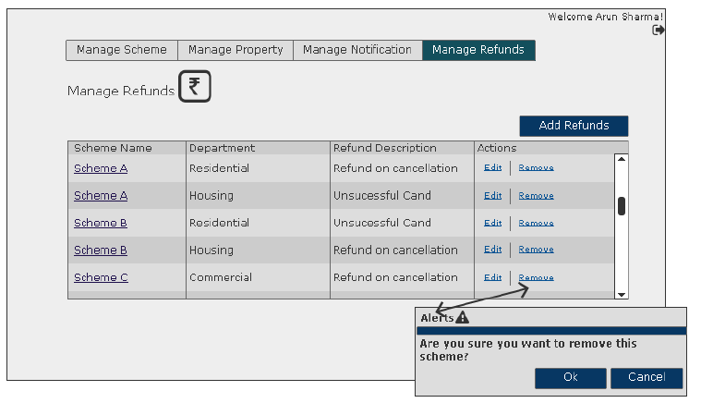
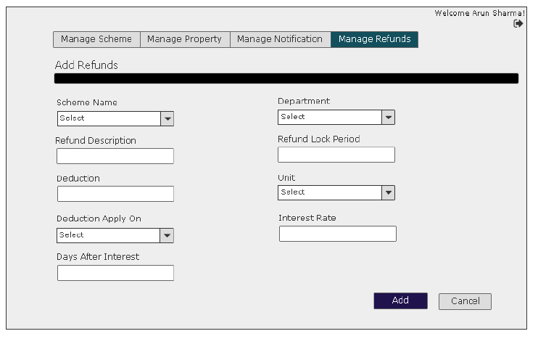

User Story - Edit Refund

Sprint | 2
User Story ID | 014
User Story Title | Manage Refund-Edit Refund
Actors | Admin
Story | As an Admin I want to update a refund details.
Pre Conditions | - Admin should be logged in to the system.
Business Criteria
Acceptance Criteria | - User would click on ‘Edit’ option from the set of options available in grid against each Refund created.  - User would get a form with the following fields:  - Scheme Name: Dropdown (mandatory)  - Department: Dropdown (mandatory)  - Refund Description: Textbox (mandatory)  - Refund lock period (no of days): Textbox (mandatory)  - Deduction: Textbox (mandatory)  - Unit: Dropdown (mandatory)  - Deduction Apply on: Dropdown (mandatory)  - Interest Rate: Textbox (mandatory)  - Days after Interest: Textbox (mandatory)  - After updating the form, user would click on ‘Update’ button to update refund successfully or alternatively, user can click on ’Cancel’ button to return to the ‘Manage Refund’ screen without making any changes.
Field Level Validation | - Refund Description: alphanumeric with only space as special character, maximum 200 characters. Validate for unique notification name.  - Refund Lock Period: Numeric, Max 5 characters.  - Deduction: Numeric  - If unit percentage, Max 3 digits, should not exceed 100 %  - If unit fixed, Max 15 digits  - Interest Rate: Numeric, max 3 digits, should not exceed 100 %  - Days after Interest: Numeric, max 5 digits  Note: All mandatory fields can’t be left blank.

Mock-ups

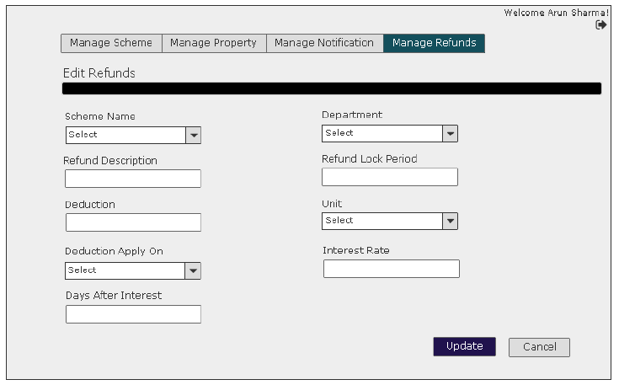

User Story - View Refund Details

Sprint | 2
User Story ID | 002
User Story Title | Manage Refund- View Refund
Actors | Admin
Story | As an admin I want to view a Refund.
Pre Conditions | Admin should be logged in to the system.
Business Criteria
Acceptance Criteria | - User would click on ‘Scheme Name’ option from the set of options available in grid against each Refund created to view the details.  - User would get a screen with the following details:  - Scheme Name  - Department Name  - Refund Description  - Refund lock Period  - Deduction details: Applied on and amount/percentage  - Interest Rate  - Days After Interest
Field level Validation

Mock-ups
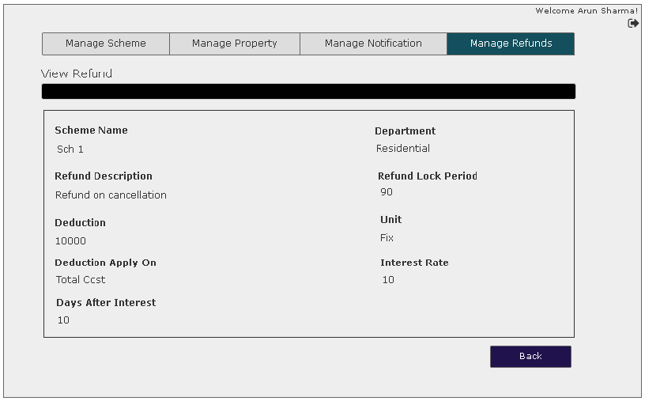

User Story - Remove Refund

Sprint | 2
User Story ID | 008
User Story Title | Manage Refund- Remove Refund
Actors | Admin
Story | As an admin I want to remove a Refund.
Pre Conditions | Admin should be logged in to the system.
Business Criteria | - All removed Refunds would only be a soft delete.
Acceptance Criteria | - User would click on ‘Remove’ option from the set of options available in grid against each Refund created.  - User would get pop up box with message as “Are you sure you want to delete?”.  - User clicks on “Ok” button and scheme is deleted from the grid.
Field level Validation

Mock-ups

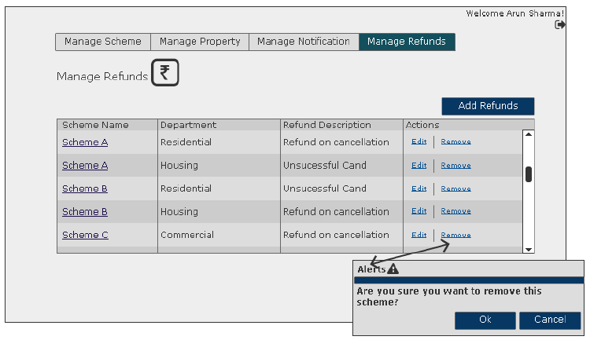

User Story – Add Circle Rate

Sprint | 2
User Story ID | 017
User Story Title | Add Circle Rate
Actors | Admin
Story | As an admin I want to add circle rate for department and their respective sectors.
Pre Conditions | Admin should be logged in to the system.
Business Criteria | - No duplicate entry can be made against department and sector on same day.  - Circle rate duration will be applicable as per below formula:  End date of circle rate = [Start date of new circle rate-1]  - End date would be generated from backend.
Acceptance Criteria | - User would click on ‘Add Circle Rate’ button under ‘Circle Rate’ menu.  - User would get a form with following fields:  - Department: Dropdown, Mandatory  - Sector: Dropdown, Mandatory  - Rate (per sq.mtr): Textbox, Mandatory  - Start Date: Date picker, Mandatory  - After filling the form, user would click on ‘Add’ button to add refund successfully to the grid. Alternatively, user can click on ’Clear’ button to reset the updated fields on the form.  - Once user successfully adds a circle rate, it would be displayed in a grid available on the circle rate screen with following columns:  - Department  - Sector  - Rate  - Start Date  - Action: “Remove”
Field level Validation | - Rate (Per sq.mtr.): Decimal (15,2)

Mock-ups

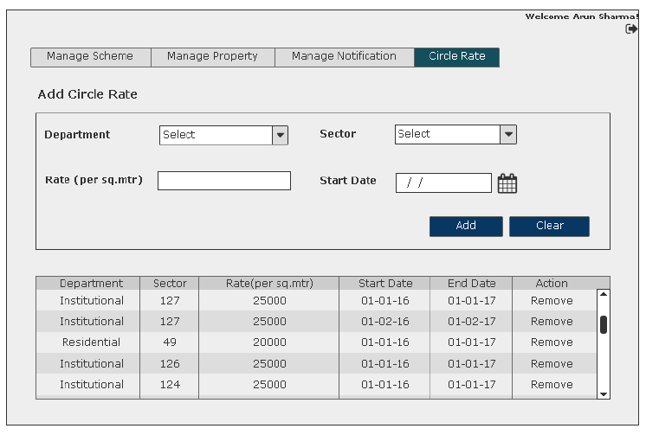

User Story - Remove Circle Rate

Sprint | 2
User Story ID | 018
User Story Title | Remove Circle Rate
Actors | Admin
Story | As an admin I want to remove a circle rate.
Pre Conditions | Admin should be logged in to the system.
Business Criteria | - All removed circle rates would only be a soft delete.
Acceptance Criteria | - User would click on ‘Remove’ option available in grid against each circle rate created.  - User would get pop up box with message as “Are you sure you want to delete?”.  - User clicks on “Ok” button and circle rate is deleted from the grid.
Field level Validation

Mock-ups
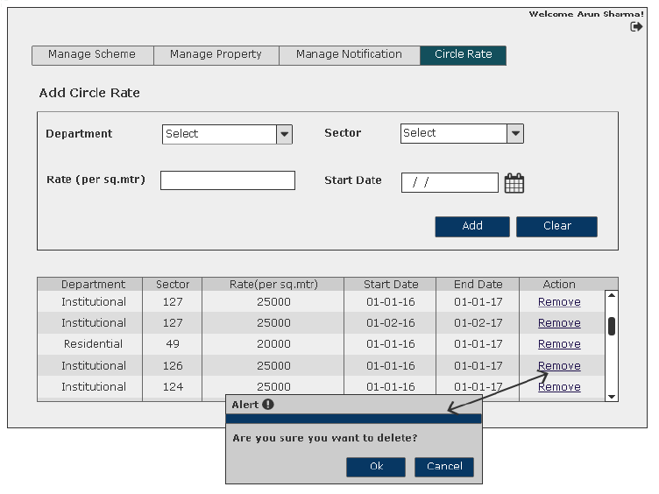

Master Data Management- Backend Data Modeling

Master Data- Quota

Sprint | 2
Master Table no | 001
Master Table Name | Quota
Description | Table for various quota for reserved properties.
Fields | - Quota Id (Auto Generated)  - Quota Name  - Is Active  - Created by  - Created Date  - Modified By  - Modified Date  Note: Use standard naming conventions for table and fields.

Master Data- Floor

Sprint | 2
Master Table no | 002
Master Table Name | Floor
Description | Table for various floors in a property.
Fields | - Floor Id (Auto Generated)  - Floor Name  - Is Active  - Created by  - Created Date  - Modified By  - Modified Date  Note: Use standard naming conventions for table and fields.

Master Data- Rebate

Sprint | 2
Master Table no | 003
Master Table Name | Rebate
Description | Table for various rebates in a scheme.
Fields | - Rebate Id (Auto Generated)  - Rebate Name  - Is Active  - Created by  - Created Date  - Modified By  - Modified Date  Note: Use standard naming conventions for table and fields.

Master Data- Sector

Sprint | 2
Master Table no | 004
Master Table Name | Sector
Description | Table for various sectors in a locality
Fields | - Sector Id (Auto Generated)  - Sector Name  - Is Active  - Created by  - Created Date  - Modified By  - Modified Date  Note: Use standard naming conventions for table and fields.

Master Data- Block

Sprint | 2
Master Table no | 005
Master Table Name | Block
Description | Table for various blocks in a sector
Fields | - Block Id (Auto Generated)  - Block Name  - Is Active  - Created by  - Created Date  - Modified By  - Modified Date  Note: Use standard naming conventions for table and fields.

Master Data- Department

Sprint | 2
Master Table no | 006
Master Table Name | Department
Description | Table for various departments or property type.
Fields | - Department Id (Auto Generated)  - Department Name  - Is Active  - Created by  - Created Date  - Modified By  - Modified Date  Note: Use standard naming conventions for table and fields.

Master Data- Property Subtype

Sprint | 2
Master Table no | 007
Master Table Name | Property Subtype
Description | Table for various property subtypes for each department.
Fields | - Department Id  - Property Subtype Id (Auto Generated)  - Property Subtype Name  - Is Active  - Created by  - Created Date  - Modified By  - Modified Date  Note: Use standard naming conventions for table and fields.

Master Data- Location

Sprint | 2
Master Table no | 008
Master Table Name | Location
Description | Table for various property locations
Fields | - Location Id (Auto Generated)  - Location Name  - Is Active  - Created by  - Created Date  - Modified By  - Modified Date  Note: Use standard naming conventions for table and fields.

Master Data- Circle Rate

Sprint | 2
Master Table no | 009
Master Table Name | Circle rate
Description | Table for location wise circle rate.
Fields | - Sector Id  - Block Id  - Department Id  - Property Subtype Id  - Circle Rate  - Unit  - Effective From  - Effective To  - Is Active  - Created by  - Created Date  - Modified By  - Modified Date  Note: Use standard naming conventions for table and fields.

Master Data- Payment mode

Sprint | 2
Master Table no | 010
Master Table Name | Payment Mode
Description | Table for various payment modes
Fields | - Payment mode Id (Auto Generated)  - Payment Mode Name  - Is Active  - Created by  - Created Date  - Modified By  - Modified Date  Note: Use standard naming conventions for table and fields.

Master Data- Accounts

Sprint | 2
Master Table no | 011
Master Table Name | Account Head
Description | Table for various accounts of receivable payments
Fields | - Account Head ID (Auto Generated)  - Account Head Name  - IS Active  - Created By  - Create Date  - Modified By  - Modified Date  Note: Use standard naming conventions for table and fields.

Master Data- Accounts subtype

Sprint | 2
Master Table no | 011
Master Table Name | Account Subhead
Description | Table for various sub accounts for each accounts type of receivable payments
Fields | - Account Head ID  - Account Subhead ID (Auto Generated)  - Account Subhead Name  - IS Active  - Created By  - Create Date  - Modified By  - Modified Date  Note: Use standard naming conventions for table and fields.

Master Data- Media

Sprint | 2
Master Table no | 012
Master Table Name | Media Type
Description | Table for different media for scheme notifications
Fields | - Media type ID (Auto Generated)  - Media Type Name  - IS Active  - Created By  - Create Date  - Modified By  - Modified Date  Note: Use standard naming conventions for table and fields.

Master Data- Media subtype

Sprint | 2
Master Table no | 013
Master Table Name | Media Subtype
Description | Table for different media subtypes for each media type.
Fields | - Media type ID  - Media Subtype ID (Auto Generated)  - Media Subtype Name  - IS Active  - Created By  - Create Date  - Modified By  - Modified Date  Note: Use standard naming conventions for table and fields.

